"Better Stands Gold Seal" for Arburg

Sustainability – also in stand construction

* Honoured: “Gold Seal” from Informa Markets for   
  Plástico Brasil 2025
* Convincing: Modular stand concept from Arburg
* International: Reusability of exhibition stand components worldwide

Lossburg, 17.04.2025

***Trade fairs and business events, which have traditionally generated large amounts of waste, including wood, plastic and fabric, can also become sustainable. Informa Markets, the organiser of the plastics trade fair*** ***Plástico Brasil, which took place in São Paulo from 24 to 28 March 2025, has launched the “Better Stands” initiative committing to the goal of eliminating exhibitor stand waste by 2030. This year’s trade fair already achieved more than 95 per cent sustainability, for example by reusing stand construction materials. Arburg, whose modular stand concept was awarded the “Better Stands Gold Seal” for its international multiple use capability, contributed significantly to this achievement.***

Arburg has long been committed to developing and manufacturing modular exhibition stands in Germany. These stands are adapted to different sizes for reuse at various trade fairs around the world. “Furniture, panels, flooring and carpets come from Germany and will be reused at countless other trade fairs after the event”, says Alfredo Fuentes, Managing Director of Arburg’s Brazilian subsidiary, explaining the concept of the sustainable stand. In this way, the company ensures that the same stand components can be (re)used at around 50 international trade fairs per year. Many of the materials and pieces of equipment have already been in use for several years without generating waste. This approach aligns with Arburg’s sustainable philosophy and supports the circular economy and resource conservation goals of the arburgGREENworld programme.

Assembly and disassembly are equally important

“For operational purposes, disassembly is almost more interesting than assembly”, says Kai Armbruster, Manager of Fairs & Events at the Arburg headquarters in Lossburg, “because it demonstrates the care that we take with every piece. That’s why our fitters come all the way from Germany to set up and dismantle our exhibition stands. Everything is pre-organised for smooth logistical handling, using custom wooden transport boxes and specialised tools. It is a very well-choreographed process.”

The sustainable stand model is also financially viable in the long term. While the initial investment is higher, since all furniture and equipment are purchased rather than rented, this strategy pays off over time.

Receiving the “Better Stands Gold Seal” is an important recognition for Arburg and was a great surprise at the trade fair. Alfredo Fuentes concludes: "This award confirms Arburg’s sustainability endeavours. It is gratifying to see that this is also becoming increasingly valued in the market."

Photo

**Better Stands Gold Seal 2025 BR_5956** 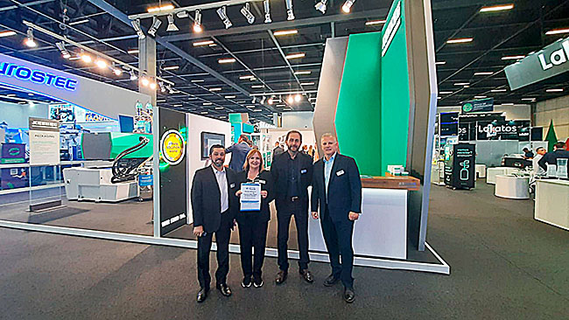

Proud Arburg Brazil team receives the “Better Stands Gold Seal” at Plástico Brasil 2025: Jeziel de Oliveira (left), Sibile Meyer and Leandro Goulart (right) with Cleverton Rias from Informa Markets (3rd from left).

Photo: Informa Markets

Photo Download:

<https://media.arburg.com/web/1993a7610571d4ea/better-stand-gold-seal-arburg-brazil/>

Press Release

File: Pressemitteilung Auszeichnung Stand Plástico Brasil_en_GB.docx

Character: 390

Words: 2.598

You can also download this and other press releases from our website at www.arburg.com/de/presse/ (www.arburg.com/en/presse/)

Contact us

ARBURG GmbH + Co KG

Press office

Susanne Palm

Dr Bettina Keck

PO Box 1109

72286 Lossburg, Germany

Phone: +49 7446 33-3463

Phone: +49 7446 33-3259

presse_service@arburg.com

About Arburg

Founded in 1923, the German family-owned company is one of the world's leading machine manufacturers for plastics processing. The ARBURG family also includes AMKmotion and ARBURGadditive including innovatiQ.

The portfolio includes injection moulding machines, 3D printers for industrial additive manufacturing, robotic systems and customer- and industry-specific turnkey solutions. It also includes digital products and services.

ARBURG is a pioneer in the plastics industry when it comes to energy and production efficiency, digitalisation and sustainability. ARBURG machines are used to manufacture plastic products for the mobility, packaging, electronics, medical, construction and apparatus engineering and leisure sectors, for example.

The company headquarters are located in Lossburg, Germany. In addition, ARBURG has its own organisations in 27 countries at 37 locations and is represented in over 100 countries together with trading partners. Of the total workforce of around 3,700, around 3,100 are employed in Germany and around 600 in the ARBURG organisations worldwide.

ARBURG is certified in accordance with ISO 9001 (quality), ISO 14001 (environment), ISO 27001 (information security), ISO 29993 (training) and ISO 50001 (energy).

Further information: www.arburg.com, www.amk-motion.com and www.arburg.com/arburgadditive.