Ecovadis Sustainability Award

Gold again for Arburg!

* Award: Gold medal from Ecovadis
* Top position: Arburg among the top five per cent
* Tradition: Sustainability firmly rooted in the company's DNA

Lossburg, 18/11/2024

***Arburg has done it again in 2024 with another Gold Medal from Ecovadis! A great achievement, especially as the requirements have been raised again compared to the previous year. Scoring a total of 78 points, Arburg was able to secure a leading position among the top five per cent of the world's most sustainable industrial companies, thereby receiving impartial confirmation of the success of its extensive sustainability activities under the arburgGREENworld programme.***

Ecovadis is a comprehensive sustainability rating platform for global supply chains.

In addition to environmental impact and sustainable procurement, the focus is also on ethics as well as labour and human rights. In all four areas, Arburg improved further compared to the previous year with its score of 78 points, putting it in the top five per cent of more than 100,000 companies whose data is evaluated by Ecovadis.

**Decades-long focus on sustainability**

"We are very proud to have once again been awarded an Ecovadis Gold Medal," says Managing Partner Michael Hehl, responsible for Premises Development and Spokesperson for the Management Team. "This is a great result for our sustainability activities. Not only does it prove that we are doing very well with our arburgGREENworld programme, but also that we are continuously improving."

"Sustainability is firmly rooted in the DNA of our family business," adds Managing Partner Juliane Hehl, who is responsible for Global Marketing and Business Development. "That's why we have always invested a great deal in the areas of sustainability and resource conservation, and on reducing our carbon footprint."

**Clear commitment to reducing greenhouse gases**

"With our climate strategy, we are pursuing greenhouse gas reduction targets validated by the Science Based Targets Initiative (SBTi)," says Michael Hehl, citing an example of the high standards that Arburg sets for itself. Arburg GmbH + Co KG is committed to achieving net-zero greenhouse gas emissions along its entire value chain by 2050. In the shorter term, the company aims to reduce absolute greenhouse gas emissions by 42 per cent in Scopes 1 and 2 and by 25 per cent in Scope 3 by 2030, followed by a long-term reduction of 90 per cent in Scopes 1, 2 and 3 by 2050.

"For years now, our Arburg Sustainability Report has been providing an overview of all arburgGREENworld topics alongside a host of interesting facts and figures,"

adds Juliane Hehl. "This year, we also published a report in accordance with Global Reporting Initiative (GRI) Standards, enabling the extensive activities of our company to be compared internationally. This is an aspect that will continue to gain in importance in the future."

Photo

**1239**

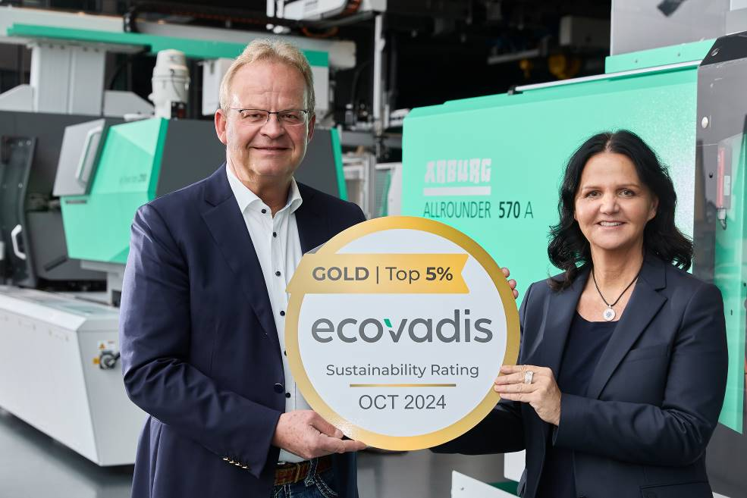

*Proud of their Ecovadis Gold Medal: Managing Partners Michael and Juliane Hehl.*

Photo: ARBURG

Photo download:

<https://media.arburg.com/web/eba18654e3c5fa03/ecovadis-gold-2024/>

Press release

File: Pressemitteilung Ecovadis Gold 2024_en_GB.docx

Characters: 2,681

Words: 429

This and other press releases are available for download from our website at www.arburg.com/de/presse/ (www.arburg.com/en/press/)

Contact

ARBURG GmbH + Co KG

Press office

Susanne Palm

Dr Bettina Keck

Postfach 1109

72286 Lossburg

Tel.: +49 (0)7446 33-3463

Tel.: +49 (0)7446 33-3259

presse_service@arburg.com

About Arburg

Founded in 1923, the German family-owned company is one of the world's leading manufacturers of plastic processing machines. The ARBURG family also comprises AMKmotion and ARBURGadditive, including innovatiQ.

Its portfolio includes injection moulding machines, 3D printers for industrial additive manufacturing, robotic systems and customer- and industry-specific turnkey solutions. It also includes digital products and services.

ARBURG is a pioneer in the plastics industry when it comes to energy and production efficiency, digitalisation and sustainability. ARBURG machines are used to manufacture plastic products for industries such as mobility, packaging, electronics, medicine, construction and equipment engineering, and leisure.

The company headquarters are located in Lossburg, Germany. In addition, Arburg has its own organisations at 37 locations in 27 countries and, together with trading partners, is represented in over 100 countries. Of a total of around 3,700 employees, some 3,100 work in Germany while around 600 are based in ARBURG organisations around the world.

ARBURG is certified in accordance with ISO 9001 (quality), ISO 14001 (environment), ISO 27001 (information security), ISO 29993 (training) and ISO 50001 (energy).

Further information can be found at: www.arburg.com, www.amk-motion.com and www.arburg.com/arburgadditive.